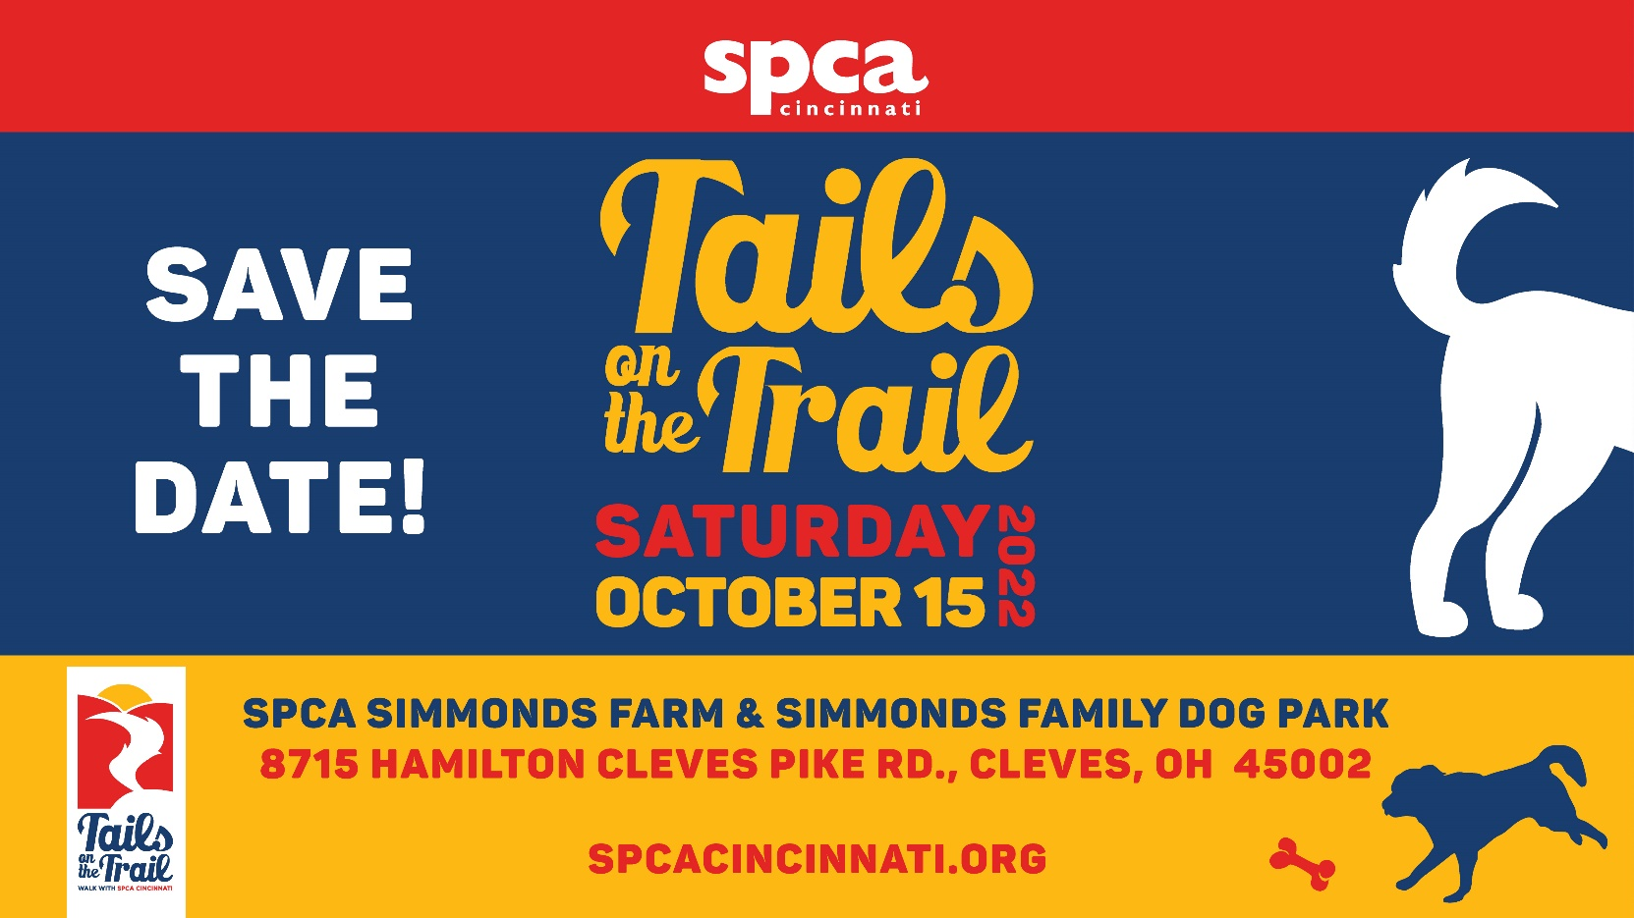

SPCA Cincinnati is honored to present you with an opportunity to sponsor our Walk event,

Tails On The Trails at SPCA Simmonds Farm & Simmonds Family Dog Park in Cleves, Ohio.

Partnering with SPCA Cincinnati’s Tails On The Trails maximizes exposure to passionate pet families in our region and establishes your brand as a partner in our lifesaving work.

Sponsoring the Tails On The Trails is also a great opportunity to build camaraderie by having your employees or clients participate as a Pack Walk Team for a leisurely walk, just under two miles. Most importantly, all proceeds raised at Tails On The Trails helps create a more humane community for animals and people in need.

Thanks to your support…
In the past 5 years, SPCA Cincinnati has:

- Rescued over 60,000 animals
- Reunited 6,000 pets with their owner
- Investigated 20,000 cases of animal cruelty
___________________________________

For more information about sponsorship opportunities, please contact Maria Miller, VP Donor Relations at mmiller@spcacincinnati.org / 513.780.6173 or visit spcacincinnati.org

2022 Tails On The Trail Vendor Form

Vendor Opportunities
___ Outreach or Marketing Vendor - $50
- Reserved for Vendors that are not selling products
- Tents will be lined up along walking trail – All Tents, Tables, & Chairs to be provided by Vendor
- Opportunity to provide literature and/or coupons to giveaway bag
  - (Deadline for getting literature/ coupons in bag – 9/30/22)

___ Sales Vendor - $100
- Reserved for vendors that are selling products to walkers and guests
- Tents will be lined up along walking trail - All Tents, Tables, & Chairs to be provided by Vendor
- Opportunity to provide literature and/or coupons to give away bag
  - (Deadline for getting literature/ coupons in bag – 9/30/22)
- SPCA Cincinnati will not provide credit card machines and/or change

Company Name: ______________________________________________________________________

Contact Name _____________________ Email ______________________ Phone _________________

Address: ____________________________________________________________________________

___ Please invoice my company at the above address

___ Check enclosed (made payable to SPCA Cincinnati)

___ Please charge my card. Credit Card #: _______________________________ Exp. Date _________

Please email, or mail this form along with payment (Deadline October 1, 2022) to Megan Roberson at:
- Email: mroberson@spcacincinnati.org
- Mailing Address: Megan Roberson, SPCA Cincinnati, 11900 Conrey Rd, Cincinnati, OH 45249

